Database Project Proposal Document

Phase 1: Requirement Gathering

1. Project Title
Apple App Store Database Management System

2. Purpose of the Project
The purpose of this project is to design and implement a comprehensive relational database system for managing the Apple App Store ecosystem. This project aims to streamline operations and improve data organization by addressing core functionalities like user accounts, app management, transactions, reviews, and in-app purchases.
The database will:
- Facilitate efficient and secure data storage and retrieval.
- Establish structured relationships among various entities to prevent redundancy.
- Support scalability to handle millions of records and concurrent users.
- Provide robust mechanisms for secure transactions and data integrity.

3. Project Description
This project focuses on building a structured database system that caters to the operations of the Apple App Store. The system will manage entities like users, apps, developers, categories, reviews, downloads, and subscriptions. The flow of the system is designed to ensure user-friendliness, operational efficiency, and system reliability.

Assumptions
- Each user is uniquely identified by a UserID and email.
- Developers can publish multiple apps, but an app belongs to only one developer.
- Each app is assigned to one category; however, a category can host multiple apps.
- Transactions are securely processed via verified payment methods.
- The system supports multiple regions with local currency and app availability settings.

Procedure and Flow
- User Registration & Browsing: Users sign up, create profiles, and browse the app store.
- App Publication: Developers create apps and submit them for approval by the system admin.
- Downloads & Subscriptions: Users download and subscribe to apps.
- Reviews & Ratings: Users leave reviews for downloaded apps, which are visible to other users.
- Payment Transactions: All transactions are securely processed, supporting various payment methods.
- Admin Oversight: Administrators monitor the database, handle approvals, and resolve support tickets.

4. Identified Entities
•Developer: Information about app creators.
•User: Information about the app store users.
•App: Details of the mobile applications available in the store.
•Subscription: Information about users' subscriptions.
•Device: Details of devices used by users.
•Support Ticket: Issues raised by users related to the app.
•Notification: Alerts for users regarding updates, promotions, etc.
•Payment: Payment records for user subscriptions or purchases.
•Operating System: The operating system on which apps run on a user’s device.
•Category: The classification of apps (e.g., games, productivity).
•Wish List: Apps that a user has saved for future downloads.

5. Attributes for Each Entity
• Developer
- developerId (Primary Key)
- developerName
- email
- contactNumber
- address
- companyName
- registerDate

• User
- userId (Primary Key)
- username
- email
- address
- password
- firstName
- lastName
- createdDate
- status (active/inactive)
• App
- appId (Primary Key)
- appName
- description
- price
- rating
- releaseDate
- developerId (Foreign Key)
- categoryId (Foreign Key)
- status (active/inactive)
• Subscription
- subscriptionId (Primary Key)
- userId (Foreign Key)
- subscriptionDate
- expiryDate
- renew (boolean)
• Device
- deviceId (Primary Key)
- userId (Foreign Key)
- deviceType
- deviceName
- serialNumber
- purchaseDate
• SupportTicket
- ticketId (Primary Key)
- userId (Foreign Key)
- issueDescription
- status
- createdDate
• Notification
- notificationId (Primary Key)
- userId (Foreign Key)
- message
- notificationDate
- readTime (nullable)
• Payment
- paymentId (Primary Key)
- userId (Foreign Key)
- amount
- paymentDate
- paymentMethod
•OperatingSystem
- operatingSystemId (Primary Key)
- name
- version
- releaseDate
- deviceId (Foreign Key)
• Category
- categoryId (Primary Key)
- categoryName
- description
- appId (Foreign Key)
• WishList
- wishListId (Primary Key)
- userId (Foreign Key)
- apps (a list of app IDs)

6. Identified Relationships Among Entities
• Developer to App: A one-to-many relationship where each developer can have multiple apps.
• User to Subscription: A one-to-one relationship where a user can have only one subscription record.
• User to Device: A one-to-many relationship where each user can have multiple devices.
• User to Support Ticket: A one-to-many relationship where a user can raise multiple support tickets.
• User to Notification: A one-to-many relationship where a user can have multiple notifications.
• User to Payment: A one-to-many relationship where a user can make multiple payments.
• App to Review: A one-to-many relationship where each app can have multiple reviews.
• App to Category: A many-to-one relationship where an app belongs to one category.
•
App to Wish List: Many-to-many, as a user can have multiple apps in their wish list.
• App to Promotion: A one-to-many relationship where a promotion can apply to multiple apps.

PHASE 2 (Marks 15)
ERD Diagram

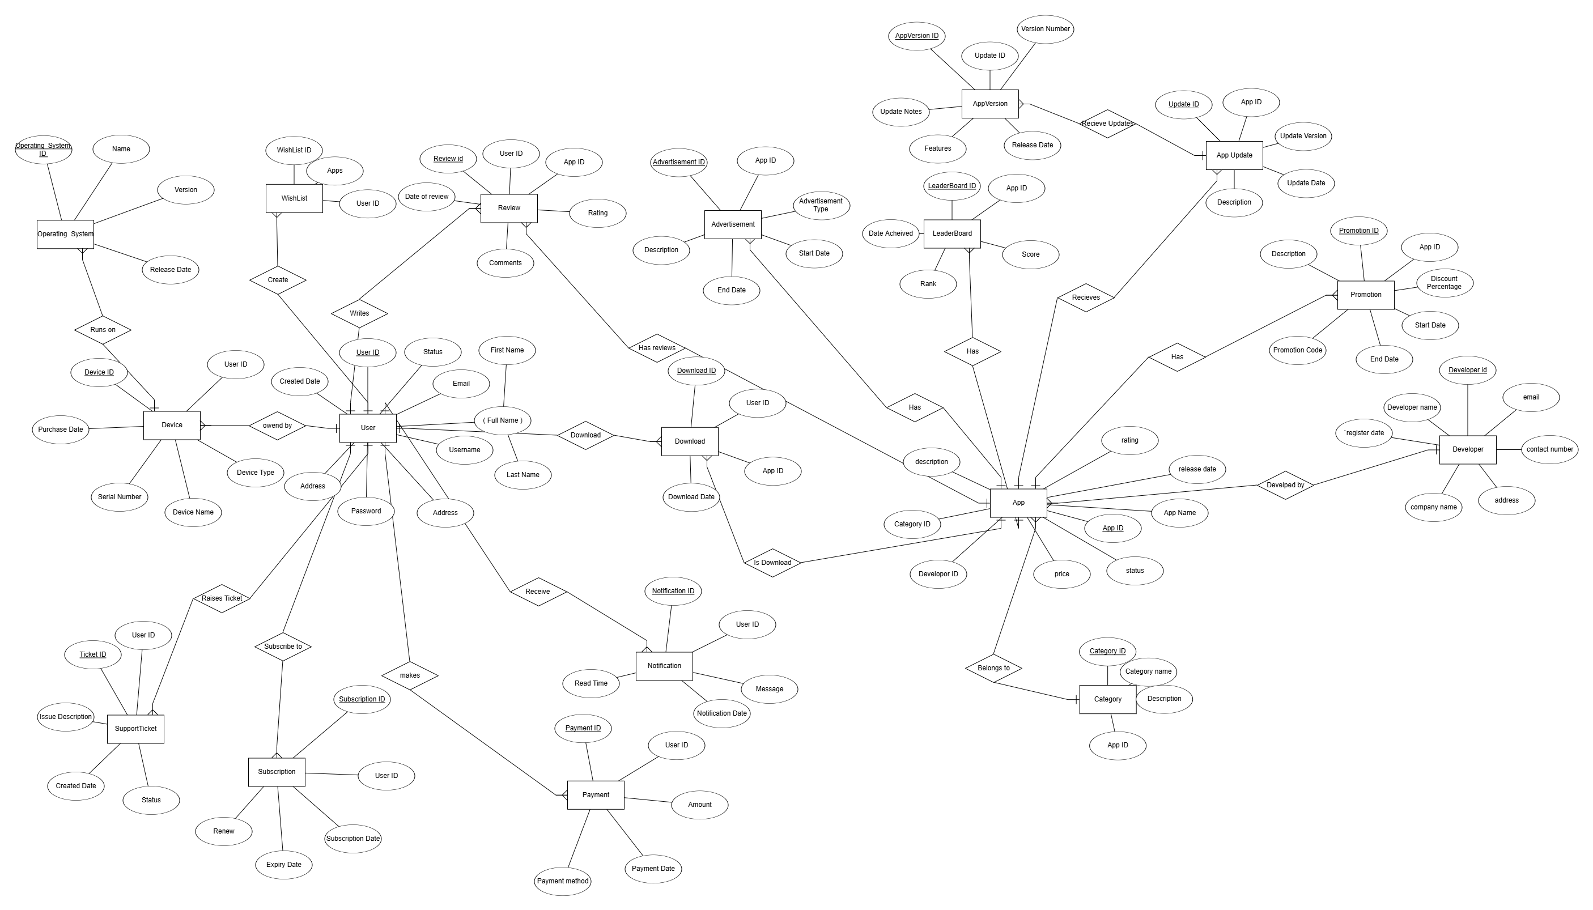

Schema

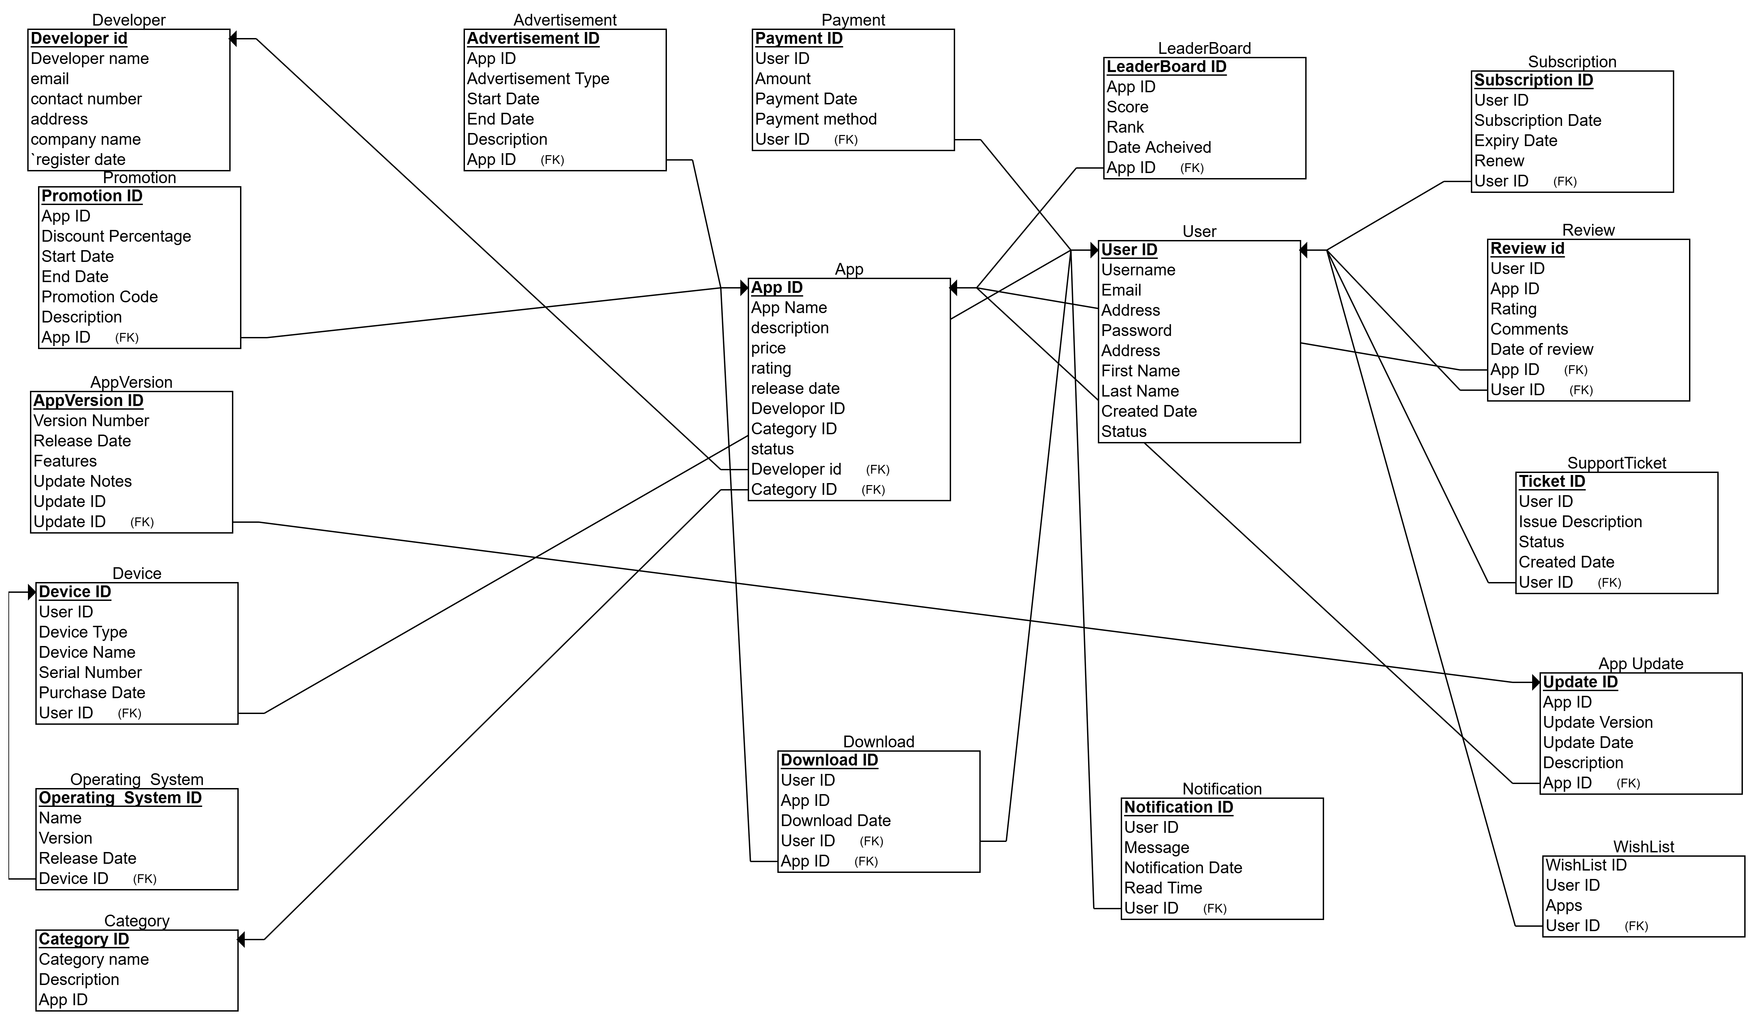

PHASE 3 (Marks 20)

SQL (QUERIES)
1: List all users, their devices, apps they have downloaded, and reviews for those apps

SELECT
U.username,
D.deviceName,
D.deviceType,
A.appName,
R.rating,
R.comments
FROM
User U
INNER JOIN Device D ON U.userId = D.userId
INNER JOIN Download Dn ON U.userId = Dn.userId
INNER JOIN App A ON Dn.appId = A.appId
INNER JOIN Review R ON A.appId = R.appId AND U.userId = R.userId;

OUTPUT:
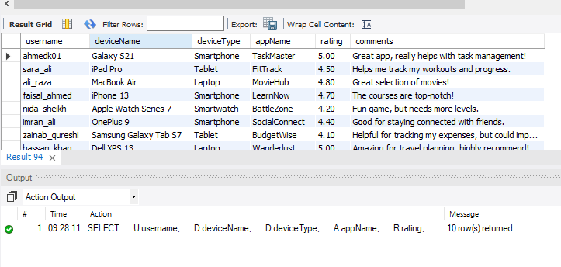
2: List all apps, their categories, user downloads, payments made, and reviews with ratings greater than 3
SELECT
A.appName,
C.categoryName,
COUNT(D.downloadId) AS downloadCount,
SUM(P.amount) AS totalPayment,
AVG(R.rating) AS averageRating
FROM
App A
INNER JOIN Category C ON A.categoryId = C.categoryId
INNER JOIN Download D ON A.appId = D.appId
INNER JOIN Payment P ON D.userId = P.userId
INNER JOIN Review R ON A.appId = R.appId
WHERE
R.rating > 3
GROUP BY
A.appName, C.categoryName;

OUTPUT:
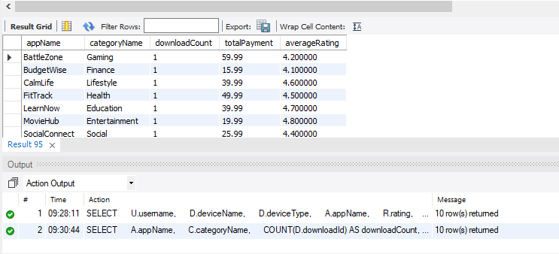

3: List users who have both downloaded apps in the "Gaming" category and made payments, along with app and payment details

SELECT
U.username,
A.appName,
C.categoryName,
P.paymentDate,
P.amount
FROM
User U
INNER JOIN Download D ON U.userId = D.userId
INNER JOIN App A ON D.appId = A.appId
INNER JOIN Category C ON A.categoryId = C.categoryId
INNER JOIN Payment P ON U.userId = P.userId
WHERE
C.categoryName = 'Gaming';
OUTPUT:
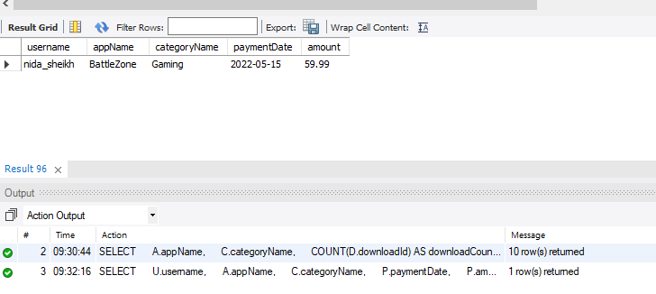
4 : Get the most popular apps (highest average ratings), their category, number of downloads, and promotion details

SELECT
A.appName,
C.categoryName,
AVG(R.rating) AS averageRating,
COUNT(D.downloadId) AS downloadCount,
P.promotionCode,
P.discountPercentage
FROM
App A
INNER JOIN Category C ON A.categoryId = C.categoryId
INNER JOIN Review R ON A.appId = R.appId
INNER JOIN Download D ON A.appId = D.appId
LEFT JOIN Promotion P ON A.appId = P.appId
GROUP BY
A.appName, C.categoryName, P.promotionCode;
OUTPUT:

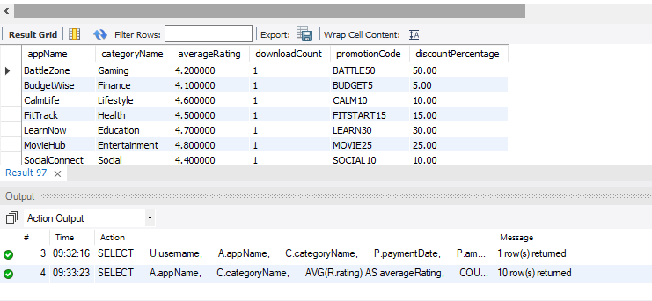
5: Get the top-rated apps that have BELOW 50 reviews, along with the developers' details and promotion information

SELECT
A.appName,
D.developerName,
AVG(R.rating) AS averageRating,
COUNT(R.reviewId) AS reviewCount,
P.promotionCode,
P.discountPercentage,
C.categoryName
FROM
App A
INNER JOIN Developer D ON A.developerId = D.developerId
INNER JOIN Review R ON A.appId = R.appId
LEFT JOIN Promotion P ON A.appId = P.appId
INNER JOIN Category C ON A.categoryId = C.categoryId
GROUP BY
A.appName, D.developerName, P.promotionCode, C.categoryName
HAVING
COUNT(R.reviewId) < 50 AND AVG(R.rating) > 4;

OUTPUT:
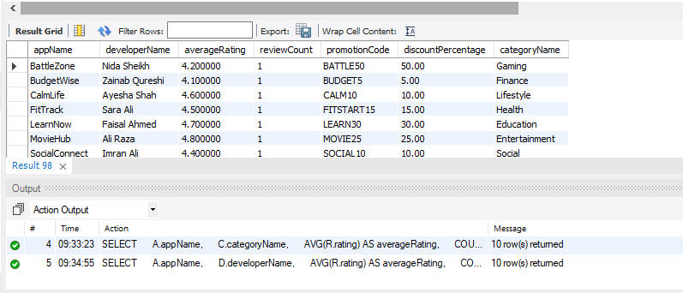

6 Retrieve user details, including device information, subscription details, payment method, app details, review information, notifications, and support ticket issues for active users.
SELECT
U.userId, U.username, U.email, U.firstName, U.lastName,
D.deviceType, D.deviceName, D.purchaseDate,
S.subscriptionDate, S.expiryDate, S.renew,
P.paymentMethod, P.amount,
A.appName, A.price, A.rating, A.releaseDate,
R.rating AS reviewRating, R.comments AS reviewComments,
N.message AS notificationMessage,
T.issueDescription AS supportTicketIssue
FROM
User U
LEFT JOIN Device D ON U.userId = D.userId
INNER JOIN Subscription S ON U.userId = S.userId
LEFT JOIN Payment P ON U.userId = P.userId
INNER JOIN Download DL ON U.userId = DL.userId
RIGHT JOIN App A ON DL.appId = A.appId
LEFT JOIN Review R ON U.userId = R.userId AND A.appId = R.appId
LEFT JOIN Notification N ON U.userId = N.userId
LEFT JOIN SupportTicket T ON U.userId = T.userId
WHERE
U.status = 'active'
ORDER BY
U.userId;
OUTPUT:
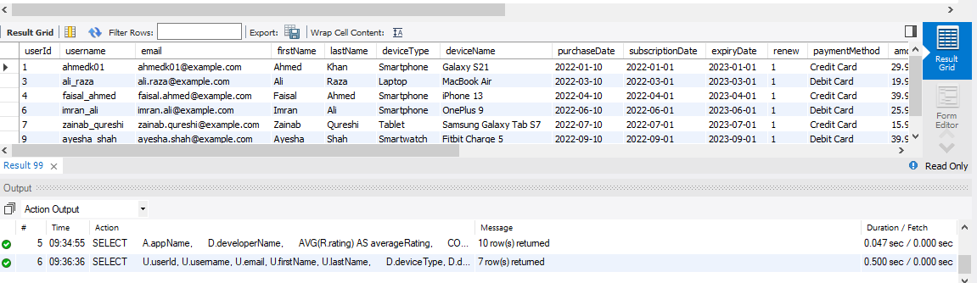

QURIES FOR Ansir
AND Hafeez

